

**Semester One**

**Examination 2024**

**Marking Guide**

**Physical Education Studies**

**Units 1&2**

Name: _______________________________________________________

Teacher: ___________________________________________________

***TIME ALLOWED FOR THIS PAPER***

Reading time before commencing work: Ten minutes

Working time for the paper: Two and half hours

***MATERIALS REQUIRED/RECOMMENDED FOR THIS PAPER***

**To be provided by the supervisor:**

* This Question/Answer Booklet

**To be provided by the candidate:**

* Standard items: pens, pencils, eraser or correction fluid, ruler, highlighter.
* Special items: Calculators satisfying the conditions set by the SCSA for this subject.

***IMPORTANT NOTE TO CANDIDATES***

No other items may be taken into the examination room. It is **your** responsibility to ensure that you do not have any unauthorised notes or other items of a non-personal nature in the examination room. If you have any unauthorised material with you, hand it to the supervisor **before** reading any further.

**Structure of this paper**

|  |  |  |  |  |  |
| --- | --- | --- | --- | --- | --- |
| Section | Number of questions available | Number of questions to be answered | Suggested working time  (minutes) | Marks available | Percentage of exam |
| Topic One:  Multiple Choice | x | x | 30 | x | 20 |
| Section Two:  Short answer | x | x | 70 | x | 50 |
| Section Three:  Extended answer | x | x | 50 | x | 30 |
|  |  |  | **Total** | x | 100 |

**Instructions to candidates**

1. The rules for the conduct of Western Australian external examinations are detailed in the *Year 11 Information Handbook 2017.* Sitting this examination implies that you agree to abide by these rules.
2. Write your answers in this Question/Answer Booklet.

Answer all questions according to the following instructions.

Multiple-Choice: Answer **all** questions on the separate Multiple-choice Answer Sheet provided. For each question shade the box to indicate your answer. Use only a blue or black pen to shade the boxes. If you make a mistake, place a cross through that square, do not erase or use correction fluid, and shade your new answer. Marks will not be deducted for incorrect answers. No mark will be given if more than one answer is completed for any reason.

Short Answer and Extended Answer: Write answers to in this Question/Answer Booklet.

1. You must be careful to confine your responses to the specific questions asked and follow any instructions that are specific to a particular question.
2. Spare pages are included at the end of this booklet. They can be used for planning your responses and/or as additional space if required to continue an answer.
   * Planning: If you use the spare pages for planning, indicate this clearly.
   * Continuing an answer: If you need to use the space to continue an answer, indicate in the original answer space where the answer is continued, i.e. give the page number. Refer to the question(s) where you are continuing your work.

**Topic: Functional Anatomy (35 marks)**

This section has **10** questions. Answer **all** questions. Answer the five **(5)** Multiple-Choice questions on the separate Multiple-choice answer Sheet provided. Write your answers to the Short Answer and Extended Answer question in the spaces provided in this Question/Answer Booklet. Wherever possible, confine your answers to the line spaces provided. Use a blue or black pen (**not** pencil) for this section.

Spare pages are included at the end of this booklet. They can be used for planning your responses and/or as additional space if required to continue an answer.

Suggested working time: 50 minutes.

**Multiple Choice (5 marks)**

1. Alveoli air sacs where oxygen is diffused are found at the end of the
2. capillaries.
3. bronchioles.
4. trachea.
5. lungs.
6. The agonist is a muscle which is
7. lengthening.
8. contracting.
9. stabilising.
10. voluntary.
11. Which blood vessel carries oxygenated blood to the heart?
12. vena cava
13. aorta
14. pulmonary vein
15. capillaries
16. The origin point for the quadriceps muscle is located on the
17. tibia.
18. femur.
19. patella.
20. pelvis.

5. Moving the arms outwards to catch and pull during breaststroke swimming would be described as

1. abduction.
2. flexion.
3. extension.
4. adduction.

**Short Answer (20 marks)**

**Question 6 (5 marks)**

Describe the mechanics of inhalation when breathing during swimming.

|  |  |
| --- | --- |
| **Answer Description** | **5 Marks Max** |
| **Inhalation (Inspiration)**  Diaphragm muscle contracts or flattens  Thoracic cavity (rib cage) expands, moves upwards/outwards  Increase in lung volume/size  Air pressure in lungs decreases (lower air pressure)  Air is drawn into lungs due to pressure differential (higher external air pressure moves to lower internal pressure) | 1-5 marks |

**Question 7 (4 marks)**

Capillaries are only one cell thick to allow for their efficient function of diffusion of oxygen and carbon dioxide. Outline **two (2)** characteristics of arteries and veins that enable them to function appropriately.

|  |  |
| --- | --- |
| **Answer Description (no mark for identification only)** | **Max 4 Marks** |
| **Arteries**  Thick and elastic walls to withstand high blood pressure and layer of smooth muscle to force blood away from the heart | 1-2 marks |
| **Veins**  Thinner walls and contain valves to prevent backflow and maintain blood pressure | 1-2 marks |

**Question 8 (4 marks)**

Label the **four (4)** bones of the leg indicated in the diagram below:

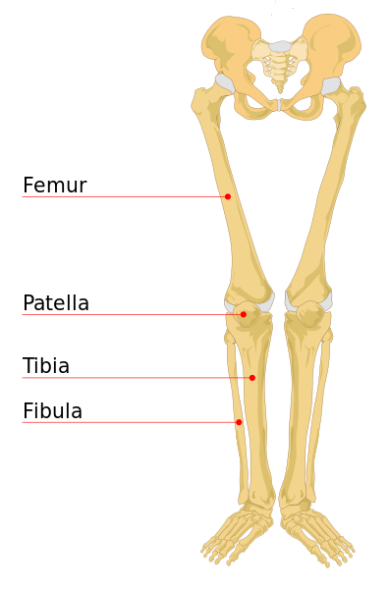

Femur

Fibula

Patella

Tibia



**Question 9 (7 marks)**

Muscles which work together are known as antagonistic pairs.

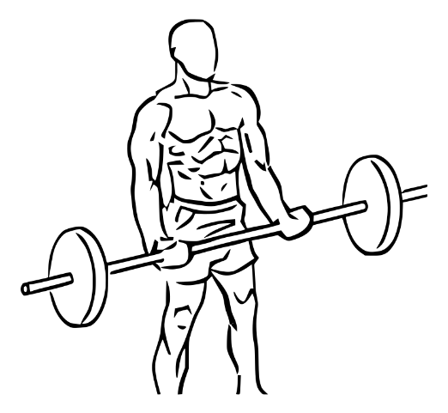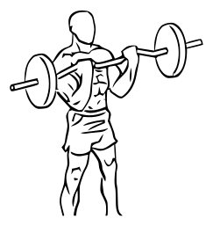

(a) When completing a bicep curl, identify and describe how muscles work in pairs to lift and lower the barbell.

(4 marks)

|  |  |
| --- | --- |
| **Answer Description (no mark for identification only)** | **Max 4 Marks** |
| **Lifting barbell**  Biceps are shortening, contracting, prime mover (agonist muscle) to allow elbow flexion.  Triceps are lengthening, relaxing (antagonist muscle) | 1-2 marks |
| **Lowering Barbell**  Biceps are contracting eccentrically (lengthening) to allow elbow extension.  Triceps are shortening & progressively relax (antagonist muscle) | 1-2 marks |

(b) Outline the types of movement at the elbow during the bicep curl. (2 marks)

|  |  |
| --- | --- |
| **Answer Description (no mark for identification only)** | **Max 2 Marks** |
| **Lifting barbell**  Flexion at the elbow (closing a joint or reducing joint angle) | 1 mark |
| **Lowering Barbell**  Extension at the elbow (opening a joint or increasing joint angle) | 1 mark |

(c) Define excitability in relation to the characteristic of skeletal muscle during the bicep curl.

(1 mark)

|  |  |
| --- | --- |
| **Answer Description** | **Max 1 Marks** |
| **Defines:** The ability of a muscle to contract in response to a stimulus or nerve impulse from the central nervous system (or similar) | 1 mark |

**Extended Answer (10 marks)**

**Question 10 (10 marks)**

Mathieu van der Poel is an outstanding cyclist having won the World Cyclo-Cross Championship on five occasions. His aerobic capacity allowed him to make a seamless transition to road cycling, where he won the World Road Race Championship in 2023 across a distance of 273km over 6 hours. Explain how oxygen enters the circulatory system and the pathway it takes to Mathieu’s working muscles and then the pathway to removing carbon dioxide from the lungs.

(10 marks)

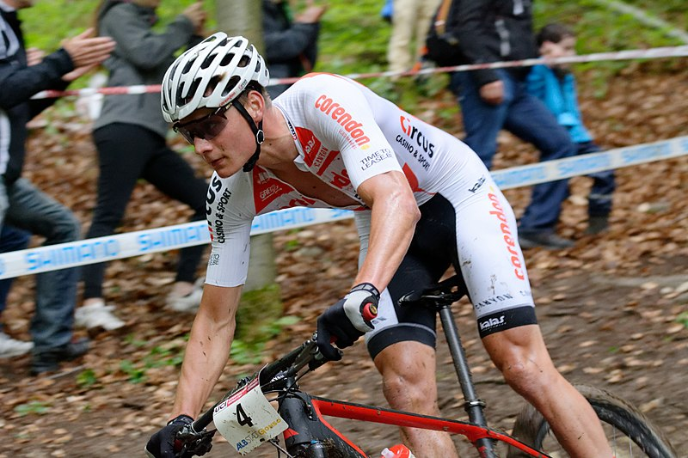

|  |  |
| --- | --- |
| **Answer Description** | **10 Marks Max** |
| Oxygen is diffused (gas exchange) in the lungs at the alveoli (air sacs) into the bloodstream | 1 mark |
| Diffusion of oxygen occurs at the capillaries which surround alveoli | 1 mark |
| Oxygenated blood travels from lungs towards heart via pulmonary vein | 1 mark |
| Oxygenated blood enters left atrium then left ventricle | 1 mark |
| Oxygenated blood exits heart via aorta travelling to working muscles via arteries | 1 mark |
| Oxygen (& nutrients) is diffused and delivered at the muscle bed via the capillaries | 1 mark |
| Carbon dioxide (& waste) is diffused and removed from the muscle bed | 1 mark |
| Deoxygenated blood is returned to the heart via veins, enters the right atrium via the vena cava | 1 mark |
| Deoxygenated blood passes into the right ventricle | 1 mark |
| Deoxygenated blood exits the heart into the pulmonary artery, back towards the lungs where carbon dioxide is diffused into the lungs and the process begins again | 1 mark |

**End of Topic**

**Topic: Exercise Physiology (35 marks)**

This section has **9** questions. Answer **all** questions. Answer the five **(5)** Multiple-Choice questions on the separate Multiple-choice answer Sheet provided. Write your answers to the Short Answer and Extended Answer question in the spaces provided in this Question/Answer Booklet. Wherever possible, confine your answers to the line spaces provided. Use a blue or black pen (**not** pencil) for this section.

Spare pages are included at the end of this booklet. They can be used for planning your responses and/or as additional space if required to continue an answer.

Suggested working time: 50 minutes.

**Multiple Choice (5 marks)**

* + - 1. What is a muscular contraction known as when muscle length remains constant or the same during contraction?
         1. isotonic
         2. isokinetic
         3. insertion
         4. isometric
      2. Which of the following would be an acute response to continuous training?

1. increased capillarisation
2. increased heart rate
3. decreased blood pressure
4. decreased ventilation rate
   * + 1. The predominant energy system utilised during a one-minute, 400m in athletics would be the
5. lactic acid system
6. ATP-CP system
7. aerobic system
8. inter-play of all three energy systems
   * + 1. Weightlifters would be best coached towards which main method of training?
9. flexibility training
10. continuous training
11. plyometrics
12. resistance training
    * + 1. When compiling a training program, which component of fitness would be of most importance to a cross country skier?
           1. muscular endurance
           2. balance
           3. speed
           4. muscular strength

**Short Answer (20 marks)**

**Question 6 (6 marks)**

Different sports require specific components of fitness based upon the demands placed on the physiological systems of the body. Complete the table below:

|  |  |  |
| --- | --- | --- |
| **Component of Fitness** | **Definition** | **Sporting Example** |
| Flexibility | The range of motion at a joint.  (or similar)  **1 mark** | Gymnastic splits |
| Agility  **1 mark** | Being able to change direction quickly and accurately in a confined area. | Basketball dribbling  (or other specific relevant example).  **1 mark** |
| Balance | Maintaining a state of equilibrium (either static or dynamic) to maintain stability.  (or similar)  **1 mark** | Ice skater |
| Reaction Time  **1 mark**  **(not speed as example is sprint start)** | Being able to react to a stimulus quickly.  (or similar)  **1 mark** | 100m sprint start |

**Question 7 (4 marks)**

Training programmes should incorporate specificity and progressive overload to place stress upon the athlete’s physiological systems, causing adaptations. Outline **two (2)** principles that any athlete can adjust as they adapt.

|  |  |
| --- | --- |
| **Answer Description (2 mark maximum for identification of two principles only)** | **Max 4 Marks** |
| **Frequency**  Increase ‘how often’ the athlete trains. e.g. training sessions per day / per week.  **Intensity**  Increase ‘how hard’ the athlete trains. e.g. increase speed, distance, weights lifted, repetitions, sets, less rest/recovery between intervals.  **Duration (Time)**  Increase ‘how long’ the athlete trains. e.g. longer training sessions, longer distance. | 1 mark  1 mark  1 mark  1 mark  1 mark  1 mark |

**Question 8 (10 marks)**

Richard is completing a 6-week training programme leading up to the National Cross Country Championships where he will compete over a 12km course in approximately 40 minutes.

(a) Identify the predominant energy system and component of fitness when competing in cross country.

(2 marks)

|  |  |
| --- | --- |
| **Answer** | **Max 2 Marks** |
| Aerobic energy system | 1 mark |
| Cardiorespiratory endurance | 1 mark |

(b) List **two (2)** training types that Richard would predominantly incorporate in his training programme.

(2 marks)

|  |  |
| --- | --- |
| **Answer** | **Max 2 Marks** |
| Continuous training | 1 mark |
| Interval training (long) or Fartlek training | 1 mark |

(c) Using your understanding of the chronic adaptations to training, describe **three (3)** effects of training on the circulatory system.

(6 marks)

|  |  |
| --- | --- |
| **Answer Description**  **1 mark for correct identification, must include increase/decrease (max 3 marks)**  **1 mark for correct description** | **Max 6 Marks** |
| **Increased cardiac hypertrophy**  Size of the heart increases, cardiac muscle strengthens, left ventricle wall thickens which allows more blood to be pumped with each beat (stroke volume) to deliver oxygenated blood to working muscles to avoid lactic acid accumulation or fatigue. | 1 mark  1 mark |
| **Decreased resting heart rate**  As the cardiac muscle (heart) is strengthened it becomes more efficient. At rest or lower intensities the heart can still pump enough oxygen to working muscles in a single beat with a lower heart rate (bpm) necessary.  At higher intensities the cardiac muscle (heart) has the increased capacity to pump more blood per beat at a higher heart rate (bpm) to provide oxygen to working muscles and avoid lactic acid accumulation. | 1 mark  1 mark |
| **Increased stroke volume**  The amount of blood pumped in one beat from the left ventricle (into aorta) is increased to supply adequate oxygen to working muscles to maintain use of the aerobic system. | 1 mark  1 mark |
| **Increased blood volume or haemoglobin levels**  Red blood cell count increase results in more haemoglobin which carries/attaches to oxygen being able to be carried/transported and delivered to working muscles when required. | 1 mark  1 mark |
| **Increased capillarisation**  Increased size, density and/or number of capillaries at the lungs (alveoli) and/or muscle bed to diffuse and supply oxygen to the working muscles and remove waste (CO2 or lactic acid) as necessary. | 1 mark  1 mark |
| **Decreased blood pressure**  Due to increased efficiency of heart cardiac muscle, arteries (increased elasticity) and capillarisation the circulatory system blood flow is more efficient | 1 mark  1 mark |

**Extended Answer (10 marks)**

**Question 9 (10 marks)**

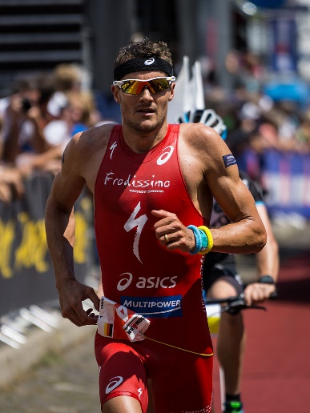The Busselton Ironman Triathlon consists of a 3.8km open water swim, 180km cycle and 42.2km run. Elite athletes can complete the course in 8 hours, whilst amateurs can take up to 16 hours to cross the finish line.

Explain how an ironman triathlete will nutritionally fuel and hydrate themselves prior and during the race to optimise their performance.

(10 marks)

|  |  |
| --- | --- |
| **Answer Description (no mark for identification only)** | **Max 10 Marks** |
| **Prior – Carbohydrate Loading**  Carbohydrate loading strategy to supplement glycogen stores in muscle and liver in the days/week leading into competition to delay glycogen depletion/fatigue.  10-12g of carbohydrate per kg of body mass for effective carbohydrate loading to be consumed in the day prior. Pasta, rice, bread etc.  Most efficient energy source to regenerate ATP at sustained higher intensity exercise. | 1-2 marks |
| **Prior - Low Glycaemic Index Foods**  Consume slow-release foods that break down slowly and release energy gradually for sustained energy release. Released into blood stream gradually to raise blood sugar.  Should be consumed as pre-event meal 2-4 hours prior to marathon. | 1-2 marks |
| **Prior – Liquids**  Hyperhydration strategy. Ensure a minimum of 2 litres of water per day is consumed in the days prior to race so fully hydrated.  Avoid dehydration which can negatively impact performance. | 1-2 marks |
| **Prior & During - High Glycaemic Index Foods**  Should be consumed as pre-event snack 15 minutes prior to competing and at intervals during race to delay (top-up) glycogen depletion in muscles and liver such as lollies, sports drinks, energy gels.  Consume high GI fast-release foods that break down (digested) quickly and release energy immediately for a short energy release during race. Released into blood stream quickly to raise blood sugar, rapid absorption.  30g-60g of simple carbohydrate per hour to supplement glycogen stores.  Avoid high fat, protein or fibre foods as they are hard to digest. | 1-2 marks |
| **During – Liquids**  Ensure ongoing hydration. 150ml – 200ml fluid every 15-20 minutes (or 600ml per hour) to avoid dehydration which can negatively impact performance.  Include electrolytes (sports drinks) to avoid cramping and replenish lost body salts through sweating. | 1-2 marks |

**End of Topic**

**Topic: Biomechanics (35 marks)**

This section has **9** questions. Answer **all** questions. Answer the five **(5)** Multiple-Choice questions on the separate Multiple-choice answer Sheet provided. Write your answers to the Short Answer and Extended Answer question in the spaces provided in this Question/Answer Booklet. Wherever possible, confine your answers to the line spaces provided. Use a blue or black pen (**not** pencil) for this section.

Spare pages are included at the end of this booklet. They can be used for planning your responses and/or as additional space if required to continue an answer.

Suggested working time: 50 minutes.

**Multiple Choice (5 marks)**

1. Maintaining the position shown in the photo below, a downhill skier would be best described as having which type of motion?

1. General motion.
2. Linear motion.
3. Angular motion.
4. Projectile motion.
5. Displacement represents which of the following?
6. the change in athlete’s position from the start to finish point
7. how far an athlete travels from the start to finish point
8. the athlete’s rate of acceleration between the start and finish point
9. the maximal velocity the athlete achieves between the start and finish point
10. When serving in Tennis, the player is aiming for the ball to accelerate as fast as possible. Which of Newton’s Laws of Motion is this applicable to?
11. Newton’s First Law of Motion.
12. Newton’s Second Law of Motion.
13. Newton’s Third Law of Motion.
14. Newton’s Fourth Law of Motion.

4. Bobsleigh requires a maximal acceleration to propel the sleigh to maximal velocity. Acceleration can best be described as the

1. amount of motion possessed by a moving body.
2. velocity an object travels in a particular direction.
3. change in velocity of an object every second.
4. force it takes to move an object.

5. In Sumo Wrestling, the aim is to destabilise their opponent in order to gain an advantage.

Which of the following statements would apply to Sumo Wrestlers when attempting to decrease the equilibrium of their opponent?

1. decreasing the size of base of support
2. increasing the mass of the body
3. raising the centre of mass
4. reducing the points of contact
5. ensuring the line of gravity is within the base of support
6. ii, iii, iv, v
7. i, iii, iv
8. iii, iv, v
9. ii, v

**Short Answer (20 marks)**

**Question 6 (10 marks)**

Sprinters must ensure that they control their balance to avoid a false start, yet also have the greatest possible acceleration from the blocks.

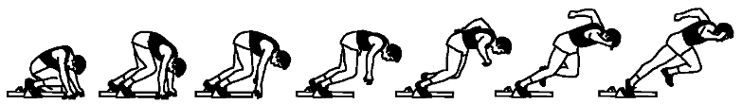(a) Identify and define the **two (2)** types of balance that the sprinter must demonstrate at the start.

(4 marks)

|  |  |
| --- | --- |
| **Answer Description** | **Max 4 Marks** |
| **Identifies:** Static Balance  **Defines:** The ability to maintain equilibrium when stationary. **Or similar wording.** | 1 mark  1 mark |
| **Identifies:** Dynamic Balance  **Defines:** The ability to maintain equilibrium when moving. **Or similar wording.** | 1 mark  1 mark |

(b) The greater the mass of the sprinter, the greater their stability. Describe how **three (3)** other principles of balance change during the sprint start sequence pictured above.

(6 marks)

|  |  |
| --- | --- |
| **Answer Description** | **Max 6 Marks** |
| **Identifies:** Centre of Gravity  **Describes:** The lower the centre of gravity the more stability the sprinter has. As they start centre of gravity moves upwards reducing stability. | 1 mark  1 mark |
| **Identifies:** Base of Support (or Points of Contact)  **Describes:** The greater the base of support the more stability the sprinter has. At the start they have a larger base of support with multiple points of contact. As they start, both base of support and points of contact reduce therefore reducing stability. | 1 mark  1 mark |
| **Identifies:** Line of Gravity  **Describes:** When line of gravity is over the base of support the sprinter has greater stability. As they start, line of gravity moves away (forwards in this case) from base of support therefore reducing stability. | 1 mark  1 mark |

**Question 7 (4 marks)**

Preparation of the neck when heading in soccer is important to generate a forceful impact upon the ball.

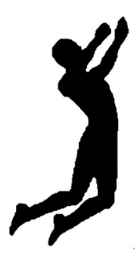

* + - * 1. Using your understanding of levers, label the components of the lever shown during the preparation phase of heading a soccer ball:

(3 marks)

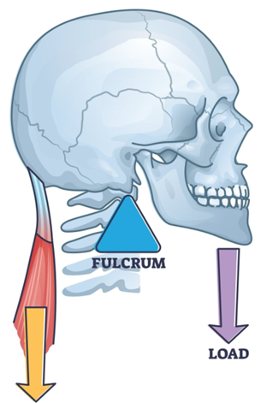

Resistance / Load

(Head/Ball)

1 mark

Force / Effort

(Muscle)

1 mark

Axis / Fulcrum / Pivot

(Neck Joint)

1 mark

* + - * 1. Identify the class of lever you have labelled. (1 mark)

|  |  |
| --- | --- |
| **Identifies** | **Max 1 Mark** |
| 1st Class Lever | 1 mark |

**Question 8 (6 marks)**

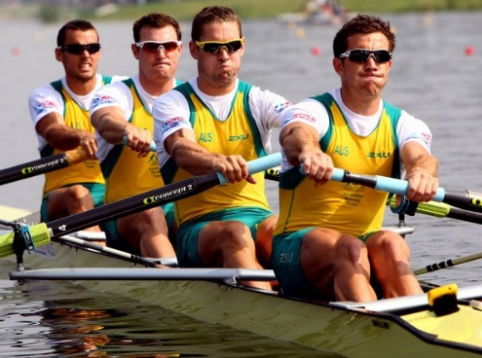Rowing requires the athletes to cover a 2km course from start to finish in a straight line as fast as possible.

Define **three (3)** types of motion providing an example of each for the rowers pictured. (6 marks)

|  |  |
| --- | --- |
| **Answer Description (no mark for motion identification)** | **Max 6 Marks** |
| **General Motion**  **Defines:** General motion that is a combination of both linear and angular motion.  **Example:** Rowers whole body. | 1 mark  1 mark |
| **Linear Motion**  **Defines:** Linear motion is when body parts move the same direction at the same time at the same speed. **Or similar wording.**  **Example:** Rowers head, torso or boat all move forwards in a linear motion. | 1 mark  1 mark |
| **Angular Motion**  **Defines:** Angular motion is when body parts rotate around an axis in a circular motion. **Or similar wording.**  **Example:** Rowers arms rotate around the axis at the shoulders. | 1 mark  1 mark |

**Extended Answer (10 marks)**

**Question 9 (10 marks)**

Golf requires both force and precision for the shot to be accurate and the ball to land as close to the hole or ‘pin’ as possible.

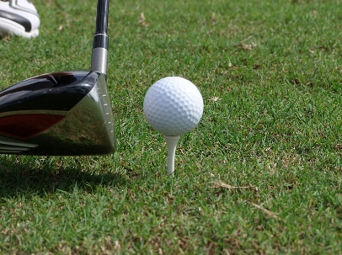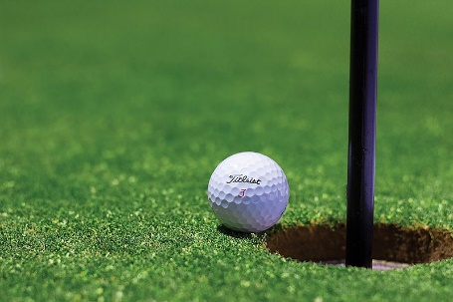

(a) Explain how Newton’s 1st and 2nd Law of Motion are applied by golfers to achieve the most accurate shot as possible.

(6 marks)

|  |  |
| --- | --- |
| **Answer Description** | **Max 6 Marks** |
| **Newton’s 1st Law**  **Defines:** An object (the ball) will remain stationary (at rest) on the tee or in its current state of motion unless acted upon by a force. **Or similar wording.**  **Explains:** The golf ball will remain stationary on the tee until the club makes contact.  The golfer needs to apply a force to it, which they do by swinging a club and hitting the ball with forces directed towards the target. | 1 mark  1 mark  1 mark |
| **Newton’s 2nd Law**  **Defines:** The acceleration of an object (the ball) is directly proportional to the force applied, will be in the direction of the force applied, and is indirectly proportional to the mass of the object. **Or similar wording.**  **Explains:** The golf ball will travel a further distance from the tee and have greater acceleration as increased force is applied. e.g. greater club/swing velocity, increased club mass. Less force will result in the golf ball accelerating less and travelling less distance e.g. putting.  Accuracy is determined by the contact being central to the club towards the pin (target). | 1 mark  1 mark  1 mark |

Elevated holes or ‘pins’ are often included as part of the golf course contours to increase difficulty. Golfers must consider the optimal trajectory or flight path of the ball in order to ensure accuracy.

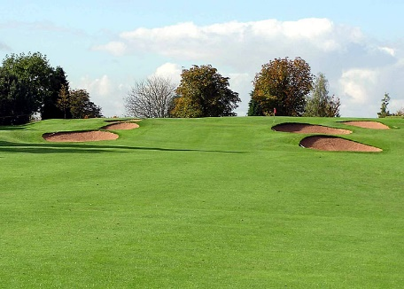

Elevated hole or ‘Pin’

(b) In relation to projectile motion, describe how a golfer will adjust their shot to gain optimal accuracy for an elevated hole or ‘pin’ for the following factors:

* Angle of Release
* Velocity of Release (4 marks)

|  |  |
| --- | --- |
| **Answer Description** | **Max 4 marks** |
| **Angle of Release**  Angle of release determines the trajectory (flight path) which needs to be high (parabolic) as landing height is above release height.  Optimal angle of release is greater than 45o (increased club angle) for optimal trajectory towards elevated hole or ‘pin’. This will increase vertical distance and flight time.  The greater the landing height above release height, the greater the angle of release for accuracy. | 1 mark  1 mark  **(2 marks maximum)** |
| **Velocity of Release**  The velocity of release will determine the height and length of the trajectory (flight path) of the ball providing all other factors are constant.  The greater the velocity of release, the greater the horizontal and vertical distance the ball will travel due to increased length of time in the air. Increase in loft or angle of club may result in increased velocity being necessary due to increase in flight time or higher vertical distance achieved.  **OR**  The flight of the ball towards an elevated target will be non-parabolic (high) and shorter than usual so the ball will not travel as far as usual. Therefore, the golfer needs to hit the ball with greater velocity to offset the shorter time in flight and reduced distance of flight. | 1 mark  1 mark  1 mark  **(2 marks maximum)** |

**End of Topic**

**Topic: Sports Psychology (35 marks)**

This section has **10** questions. Answer **all** questions. Answer the five **(5)** Multiple-Choice questions on the separate Multiple-choice answer Sheet provided. Write your answers to the Short Answer and Extended Answer question in the spaces provided in this Question/Answer Booklet. Wherever possible, confine your answers to the line spaces provided. Use a blue or black pen (**not** pencil) for this section.

Spare pages are included at the end of this booklet. They can be used for planning your responses and/or as additional space if required to continue an answer.

Suggested working time: 50 minutes.

**Multiple Choice (5 marks)**

* + - 1. Using selective attention to focus upon relevant stimuli during a golf tee off shot would benefit performance by
  1. increasing arousal.
  2. increasing self-confidence.
  3. improving concentration.
  4. reducing stress.
     + 1. Which of the following statements about arousal is correct?

1. weightlifting requires a low level of arousal for optimal performance
2. novice performers require a high level of arousal for optimal performance
3. golf putting requires a low level of arousal for optimal performance
4. gymnastics beam requires a high level of arousal for optimal performance
   * + 1. An Australian Football player must try to ‘block-out’ irrelevant cues or distractions when kicking for goal to increase success. The players attentional focus is
5. narrow and internal.
6. narrow and external.
7. broad and internal.
8. broad and external.
   * + 1. Joe sets himself a goal to reduce his 1500m time by 3 seconds per week over a 4 week training programme to achieve a personal best at his Inter-School Athletics Carnival. What type of goal is this?
9. personal goal
10. performance goal
11. outcome goal
12. process goal
    * + 1. Motivation for involvement in physical activity can be influenced by which of the following?
13. age, stress and type of activity
14. age, skill level and self-confidence
15. age, skill level and arousal regulation
16. age, skill level and type of activity

**Short Answer (20 marks)**

**Question 6 (3 marks)**

Psychological arousal regulation is important for all sporting competitions. Label the Inverted U hypothesis graph below.

(3 marks)

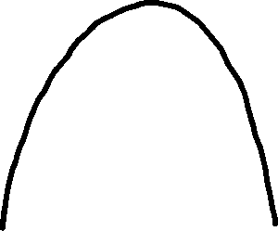

Optimal arousal (or ‘in the zone’)

Performance

Arousal

Under aroused

|  |  |
| --- | --- |
| **Labelled Graph** | **Max 3 Marks** |
| Performance (Y Axis)  Peak of curve – optimally aroused or ‘in the zone’  Left of curve – under aroused | 1 mark  1 mark  1 mark |

**Question 7 (4 marks)**

Michael Jordan was famous for consistently making game winning shots under pressure. When interviewed, he always commented that he was confident in his ability to successfully make the ‘clutch’ shot and always thought his game winning shots would be successful.

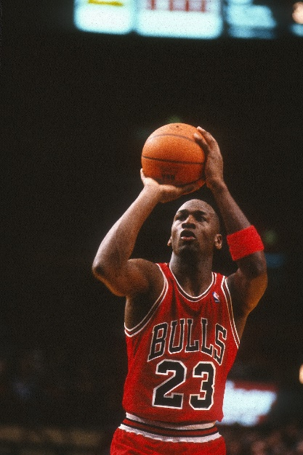

(a) Define self-confidence. (1 mark)

|  |  |
| --- | --- |
| **Defines** | **1 Mark** |
| The belief that a performer has in their own ability to successfully perform a desired skill or behaviour. **Or similar wording.** | 1 mark |

(b) Michael Jordan was often described as being ‘in the zone’. List **three (3)** possible psychological relaxation strategies that any athlete may choose to utilise to optimise their performance for success.

(3 marks)

|  |  |
| --- | --- |
| **Answer Description** | **Max 3 Marks** |
| Imagery / Visualisation  Positive Self-Talk  Pre-Performance Routine  Relaxation Techniques – **must specify one** (Progressive Muscle Relaxation, Meditation, Centring etc.) | 1 mark  1 mark  1 mark  1 mark |

**Question 8 (9 marks)**

Agreeing on a realistic goal with your coach for a forthcoming Inter-School Cross Country race can positively affect motivation to help achieve a personal best time.

(a) List **five (5)** other characteristics of effective goal setting. (5 marks)

|  |  |
| --- | --- |
| **Identifies** | **Max 5 Marks** |
| Identifies **SMARTER** Goals **(no mark for agreed/accepted or realistic)**  Specific  Measurable  Time based  Effective / Exciting  Reviewed / Recorded | 1 mark  1 mark  1 mark  1 mark  1 mark |

(b) Maintaining motivation during a training programme can be challenging; however, setting realistic performance and outcome goals can raise motivation. Outline performance and outcome goals and provide a possible example for an Inter-School Cross Country race.

(4 marks)

|  |  |
| --- | --- |
| **Answer Description** | **Max 4 Marks** |
| **Performance Goals**  Based upon personal targets that are within the control of the athlete. Not influenced by others (opposition). Can be part of the short-term process leading to long term outcome. **Or similar wording.**  e.g. sets a time to achieve (personal best), average pace to maintain, distance to train per session. | 1 mark  1 mark  **(Max 2 marks)** |
| **Outcome Goals**  Focuses on the result of performance or the race. Can be outside of control of the athlete due to influence of others (opposition). Often the long-term goal, performance goal will possible lead to a successful outcome goal. **Or similar wording.**  e.g. winning the race, placing top 3, qualifying for nationals. | 1 mark  1 mark  **(Max 2 marks)** |

**Question 9 (4 marks)**

Motivation is an important factor in the pathway to achieve long term goals. Describe the **two (2)** types of motivation and provide a sporting example for each.

(4 marks)

|  |  |
| --- | --- |
| **Answer Description (no mark for identifying)** | **Max 4 Marks** |
| **Intrinsic Motivation**  The enjoyment / fun / personal satisfaction / internal drive of the player / athlete.  Person centred, driven by internal / intangible rewards from performing the task.  **Or similar wording.**  **Examples:** Setting a personal best / personal fitness / weight loss / social enjoyment / representing country / participation for fun. | 1 mark  1 mark |
| **Extrinsic Motivation**  The external drive / reasons for competing in sport.  Driven by external / tangible rewards from performing the task.  **Or similar wording.**  **Examples:** Medals / trophies / professional contract / prize money / sponsorship. | 1 mark  1 mark |

**Extended Answer (10 marks)**

**Question 10 (10 marks)**

Nideffer’s Model of Attentional Control indicates that different sports and skills require varying attentional demands across the dimensions of direction and width. Optimal focus must be directed appropriately.

(a) Label the **four (4)** attentional factors of the direction and width dimensions on the diagram below.

(4 marks)

|  |  |
| --- | --- |
| **Answer Description** | **Max 4 Marks** |
| **Correctly labels Nideffer’s Model**   * Labelled Broad & Narrow (Horizontal axis) * Labelled External & Internal (Vertical axis) | 2 marks  2 marks |

External (1 mark)

Narrow (1 mark)

Internal (1 mark)

Broad (1 mark)

**Direction**

**Width**

**1.**

Relevant sports example (1 mark)

Relevant justification (2 marks)

**2.**

Relevant sports example (1 mark)

Relevant justification (2 marks)

(b) Identify a specific sporting skill of choice at points **1.** and **2.** indicated on the graph above relevant to the labelled attentional focus and dimensions axis.

(2 marks)

|  |  |
| --- | --- |
| **Answer Description** | **Max 2 Marks** |
| **1. Relevant sporting example for broad external sporting skill.**  e.g. pass during open play in soccer/hockey/rugby/basketball. | 1 mark |
| **2.Relevant sporting example for narrow internal sporting skill**  e.g. gymnast focus upon routine, mental rehearsal, golfer visualising shot/put. | 1 mark |

(c) Justify your choices for the specific skills chosen, outlining the sporting context and attentional requirements.

(4 marks)

|  |  |
| --- | --- |
| **Answer Description** | **Max 4 Marks** |
| **1. Relevant justification of choice.**  e.g. multiple stimuli/cues to attend to, open external environment, changing circumstances, player movement always different, multiple choices of skill to execute, team sport with continually changing environment. | 1 mark per valid point  **(Max 2 marks)** |
| **2. Relevant justification of choice.**  e.g. limited stimuli/cue to attend to, closed environment, controllable circumstances, limited choices of skill to execute, focus on specific cue | 1 mark per valid point  **(Max 2 marks)** |

**End of Topic**

**Topic: Motor Learning & Coaching (35 marks)**

This section has **9** questions. Answer **all** questions. Answer the five **(5)** Multiple-Choice questions on the separate Multiple-choice answer Sheet provided. Write your answers to the Short Answer and Extended Answer question in the spaces provided in this Question/Answer Booklet. Wherever possible, confine your answers to the line spaces provided. Use a blue or black pen (**not** pencil) for this section.

Spare pages are included at the end of this booklet. They can be used for planning your responses and/or as additional space if required to continue an answer.

Suggested working time: 50 minutes.

**Multiple Choice (5 marks)**

* + 1. Feedback provided to a basketball team from their coach on the sideline during play would be classified as

1. terminal.
2. concurrent.
3. distracting.
4. positive.
   * 1. Triple Jump would be best classified as a
5. fine skill.
6. open skill.
7. continuous skill.
8. serial skill.
   * 1. A Year 11 student achieving a personal best in their Inter-House 50m Freestyle Swimming event would be classified as which type of feedback?
9. knowledge of performance
10. knowledge of result
11. concurrent
12. positive
    * 1. Which of the following is an example of an athlete utilising proprioception to improve performance?
13. gymnast contracting their muscles to push off when vaulting
14. swimmer adjusting their hand position to feel the catch of the water
15. netball player changing direction to evade a defender
16. golfer changing their choice of club after looking at the distance of the pin (hole)
    * 1. Which of the following are the purposes of feedback?
         + 1. reinforcement of correct skill execution
           2. modification of future performance
           3. increase motivation
           4. all of the above

**Short Answer (20 marks)**

**Question 6 (7 marks)**

Past Chicago Bulls coach Phil Jackson was known for providing elite basketball players effective and timely feedback before, during and after skill execution to improve performance in the future.

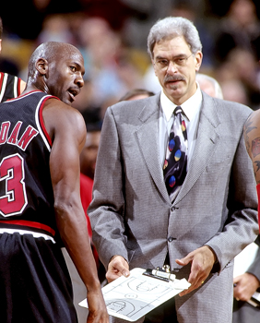

(a) Identify **two (2)** types of extrinsic or augmented feedback. (2 marks)

|  |  |
| --- | --- |
| **Answer Description** | **Max 2 marks** |
| Terminal (Knowledge of Results or Knowledge of Performance)  Concurrent  Verbal  Non-verbal | 1 mark  1 mark  1 mark  1 mark |

(b) Outline intrinsic feedback providing a sporting example. (3 marks)

|  |  |
| --- | --- |
| **Answer Description** | **Max 3 marks** |
| Intrinsic feedback is the physical feel of the skill/movement as it is being performed. It is what is felt by the performer as they execute a skill or performance.  It can felt / learnt through kinaesthesis or proprioception.  **Relevant sporting example**. e.g. a gymnast will feel off balance and correct themselves to avoid falling. | 1 mark  1 mark  1 mark |

(c) A coach can provide proprioceptive cues to improve future performance. Identify **two (2)** other cues a coach can utilise to help sports people.

(2 marks)

|  |  |
| --- | --- |
| **Answer Description** | **Max 2 marks** |
| Visual cues  Verbal cues | 1 mark  1 mark |

**Question 7 (7 marks)**

The Fitts and Posner Motor Learning Model provides the characteristics of performance within each phase of learning.

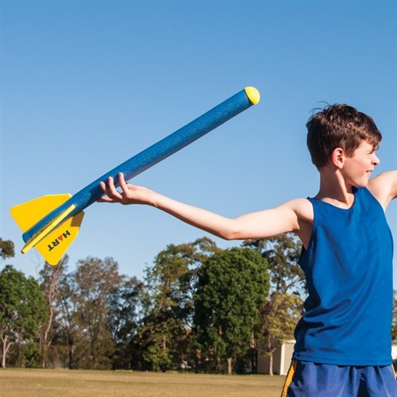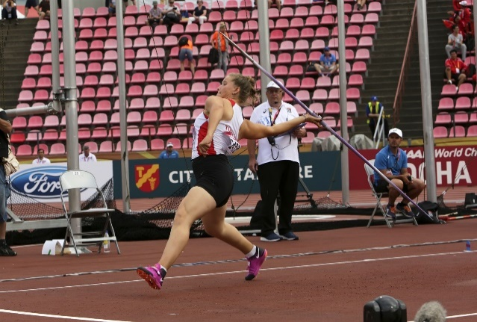

**Image A Image B**

(a) Identify the phases of learning shown in the images. (2 marks)

|  |  |
| --- | --- |
| **Answer Description** | **Max 2 Marks** |
| Image A - Cognitive Phase  Image B - Autonomous Phase | 1 mark  1 mark |

(b) Describe **two (2)** of the skill characteristics that you would expect for each of the images.

(4 marks)

|  |  |
| --- | --- |
| **Answer Description** | **Max 4 Marks** |
| Image A - Cognitive Phase  **Characteristics**  Large / gross errors made in relation to technique of running, passing, body coordination, positional understanding, rules.  Inconsistent / inefficient / unsuccessful / uncoordinated / jerky skill execution.  Can only focus on limited external stimuli.  No proprioceptive or kinaesthetic awareness or understanding of how the skill feels.  Rapid improvement.  **Or other relevant phase characteristics.** | 1-2 marks |
| Image B - Autonomous Phase  **Characteristics**  Performer’s movements are fluent, accurate and effortless.  Errors are very rare, consistency of success is very high.  Adjusts to constant changing varying environments in gameplay, speed, accuracy and correct decision making (response selection).  Can attend / process to multiple relevant cues (stimuli). Selective attention is high and can avoid distractions.  Skills are executed without conscious thought (automated) from long term memory.  Decision making can focus upon the application of tactics and strategies.  **Or other relevant phase characteristics.** | 1-2 marks |

(c) Identify the longest phase of learning. (1 mark)

|  |  |
| --- | --- |
| **Answer Description** | **Max 1 Marks** |
| Associative Phase | 1 mark |

**Question 8 (6 marks)**

Archery can be classified as a skill by the characteristics it exhibits.

(a) Using a circle, clearly classify archery on the skill continuums below. (3 marks)

(b) Justify your reason for the classification chosen under the continuum. (3 marks)

**Fine**

**Gross**

|  |  |
| --- | --- |
| **Answer Description** | **Max 2 marks** |
| Must place circle (or indicate) far left **fine.**  **Justification:**  Archery arrow release requires small muscle movements requiring precision and coordination due to small target for accuracy (high score).  **Accept:** Middle if they justify it also controls muscular strength. | 1 mark  1 mark |

**Serial**

**Continuous**

**Discrete**

|  |  |
| --- | --- |
| **Answer Description** | **Max 2 marks** |
| Must place circle (or indicate) far right **discrete.**  **Justification:**  Archery has a definite / observable / clear start and finish. Must be restarted upon conclusion. Arrow must be reloaded. | 1 mark  1 mark |

**Open**

**Closed**

|  |  |
| --- | --- |
| **Answer Description** | **Max 2 marks** |
| Should/could place circle (or indicate) in the **middle or right.**  **Relevant Justification:**  **Middle:** Archery could be performed in a variable / changing environment. e.g. wind direction, strength.  **Closed:** Archery is not affected by opposition; it is a repeated skill that is the same (minimal changes) every time. e.g. distance of target, target size, loading arrow, bow is the same. | 1 mark  1 mark |

**Extended Answer (10 marks)**

**Question 9 (10 marks)**

Being an unexpected tenth penalty taker, Cortnee Vine controlled her nerves to score the winning penalty against France in the World Cup Quarter-Final to win 7-6 in the shootout in 2023!

(a) Complete the following flow chart that outlines each stage of the Information Processing Model.

(6 marks)

**Input**

Identification of stimulus/cues by sensory system (sight, sound, touch) or perceptual mechanism from environment. (1 mark)

**Response Identification / Decision Making / Processing** (1 mark)

Information analysed, interpreted and a decision or response is selected by brain. (1 mark)

**Output**

Message is sent via central nervous system to muscles and movement is initiated. (1 mark)

**Feedback** (1 mark)

Information about success or outcome of performance is received. Internal or external. (1 mark)

(b) Outline a specific example of each stage of the Information Processing Model to Cortnee Vine’s winning penalty.

(4 marks)

|  |  |
| --- | --- |
| **Answer Description** | **Max 4 marks** |
| **Input**  Position of goalkeeper, movement of goalkeeper, size of goal, ball.  **Or relevant specific example.**  **Decision Making**  Choice of shot/response: aim low, high, left, right, corner, centre. Based upon goalkeepers’ movement or premeditated. Considers success or risk, maybe based upon past experience.  **Or relevant specific example.**  **Output**  Execution of the shot. Angle of foot, power, force, angle, velocity, direction, height, follow through.  **Or relevant specific example.**  **Feedback**  Internal: Kinaesthetic feedback that the ball was struck well, effective contact, accurate. Knowledge of Performance.  External: Score or miss, hit the net or post, saved. Knowledge of Result.  **Or relevant specific example.** | 1 mark  1 mark  1 mark  1 mark |

**End of Topic**

**ACKNOWLEDGEMENTS**

**Functional Anatomy**

Question 8

Image of leg bones

[**https://commons.wikimedia.org/wiki/File:Human_leg_bones_labeled.svg**](https://commons.wikimedia.org/wiki/File:Human_leg_bones_labeled.svg)

Question 9

Image of bicep barbell curl

[**https://commons.wikimedia.org/wiki/File:Bicep_curls_with_barbell_1.svg**](https://commons.wikimedia.org/wiki/File:Bicep_curls_with_barbell_1.svg)

[**https://en.wikipedia.org/wiki/Bicep_curl**](https://en.wikipedia.org/wiki/Bicep_curl)

Question 10

Image of Mathieu van der Poel

[**https://commons.wikimedia.org/wiki/File:Mathieu_van_der_Poel_Albstadt_2018.jpg**](https://commons.wikimedia.org/wiki/File:Mathieu_van_der_Poel_Albstadt_2018.jpg)

**Exercise Physiology**

Question 9

Image of triathlete Jan Frodeno

[**https://commons.wikimedia.org/wiki/Category:Jan_Frodeno**](https://commons.wikimedia.org/wiki/Category:Jan_Frodeno)

**Biomechanics**

Question 1

Image of downhill skier

[**https://commons.wikimedia.org/wiki/File:Andrej_%C5%A0porn_at_the_2010_Winter_Olympic_downhill.jpg**](https://commons.wikimedia.org/wiki/File:Andrej_%C5%A0porn_at_the_2010_Winter_Olympic_downhill.jpg)

Question 5

Image of Sumo wrestling

[**https://commons.wikimedia.org/wiki/File:Sumo_Wrestling_-_Tokyo_%28cropped%29.jpg**](https://commons.wikimedia.org/wiki/File:Sumo_Wrestling_-_Tokyo_%28cropped%29.jpg)

Question 6

Image of sprint start sequence

[**https://www.semanticscholar.org/paper/The-effect-of-muscular-pre-tensing-on-the-sprint-Guti%C3%A9rrez-D%C3%A1villa-Dapena/1e04d629eeaf70b0a01e28556e6ac5fb08dff129**](https://www.semanticscholar.org/paper/The-effect-of-muscular-pre-tensing-on-the-sprint-Guti%C3%A9rrez-D%C3%A1villa-Dapena/1e04d629eeaf70b0a01e28556e6ac5fb08dff129)

Question 7

Image of soccer heading

**<https://www.mdpi.com/2076-3417/12/21/10886>**

Question 7

Image of 1st class lever

[**https://www.shutterstock.com/image-vector/lever-systems-human-body-neck-leg-2187989347**](https://aus01.safelinks.protection.outlook.com/?url=https%3A%2F%2Fwww.shutterstock.com%2Fimage-vector%2Flever-systems-human-body-neck-leg-2187989347&data=05%7C01%7Cbstreeter%40pmacs.wa.edu.au%7Cce0714789d0e4e37833608dbb4c15e19%7Cfaa5dde3cbf548e0bf3334e2cedfcd6c%7C0%7C0%7C638302514847818722%7CUnknown%7CTWFpbGZsb3d8eyJWIjoiMC4wLjAwMDAiLCJQIjoiV2luMzIiLCJBTiI6Ik1haWwiLCJXVCI6Mn0%3D%7C3000%7C%7C%7C&sdata=UfOdTBokjBn2t0K5EyE%2FSkxHFd5FGMI0CVG2n6I9z3I%3D&reserved=0)

Question 8

Image of rowers

[**https://www.wikiwand.com/en/Matt_Ryan_(rower)**](https://www.wikiwand.com/en/Matt_Ryan_(rower))

Question 9

Image of golf ball on tee

[**https://commons.wikimedia.org/wiki/File:Golf_ball_on_tee.jpg**](https://commons.wikimedia.org/wiki/File:Golf_ball_on_tee.jpg)

Question 9

Image of golf ball near hole

[**https://commons.wikimedia.org/wiki/File:Ball_Near_Golf_Hole.jpg**](https://commons.wikimedia.org/wiki/File:Ball_Near_Golf_Hole.jpg)

Question 9

Image of elevated golf pin

[**https://commons.wikimedia.org/wiki/File:Golf_bunkers_Filton.jpg**](https://commons.wikimedia.org/wiki/File:Golf_bunkers_Filton.jpg)

**Sports Psychology**

Question 7

Image of Michael Jordan

**<https://www.dreamstime.com/michael-jordan-chicago-bulls-game-action-regular-season-image212463578>**

**Motor Learning & Coaching**

Question 6

Image of Phil Jackson

[**https://commons.wikimedia.org/wiki/File:Phil_Jackson_Lipofsky.JPG**](https://commons.wikimedia.org/wiki/File:Phil_Jackson_Lipofsky.JPG)

Question 7

Image of turbo javelin

[**https://www.hartsport.com.au/hart-foam-javelin-long**](https://www.hartsport.com.au/hart-foam-javelin-long)

Question 7

Image of javelin thrower

[**https://www.dreamstime.com/tampere-finland-july-munevver-hanci-turkey-javelin-throw-event-iaaf-world-u-championship-image135853107**](https://www.dreamstime.com/tampere-finland-july-munevver-hanci-turkey-javelin-throw-event-iaaf-world-u-championship-image135853107)

Question 8

Image of archery

[**https://commons.wikimedia.org/wiki/File:WA_target_shot_with_a_compound_bow_%28Devizes_Bowmen%29.jpg**](https://commons.wikimedia.org/wiki/File:WA_target_shot_with_a_compound_bow_%28Devizes_Bowmen%29.jpg)

WATP acknowledges the permission of the School Curriculum and Standards Authority in providing instructions to students.